Release build apk process

APK process for next environments:

Making new project
- updated bundle ID "com.sap.sam.mosaic.dev.release.first" to "com.sap.sam.mosaic.qa.release.first" in mdkproject.json
- updated QA service connection settings in brandedsettings.json --> use mobile settings exchanges -->info

Process :
- Update Code from BAS.
- Update app version and AndroidVersionCode in MDKProject.json. and for cloud build rebuild same job so that build version is incremented.
"AppVersion": "2.0", "AndroidVersionCode" : "2",
- Create-client.cmd using SAM_QA.mdkproject at C:\Users\jkulkarni\Documents\mosaic\MDK\ssam\MDKCLNT03P_9-70006754\MDKClient_SDK\
- Once client is generated then changes in androidmanifest.xml and android:extractNativeLibs="true" and in app.gradle abiFilters (only keep 64 bit)
- Use same certificate/keystore at C:\Users\jkulkarni\Documents\mosaic\MDK\ssam\MDKCLNT03P_9-70006754\MDKClient_SDK\release.keystore.
- Build using command tns build android --release --key-store-path C:\Users\jkulkarni\Documents\mosaic\MDK\ssam\MDKCLNT03P_9-70006754\MDKClient_SDK\release.keystore --key-store-password M0sa!c@2210 --key-store-alias client --key-store-alias-password M0sa!c@2210
- Check APK using Sixo Online APK Analyzer | sisik. Updated ID should appear in the app ID.
- Checklist apk size, bundle ID, 64bit, certificate,debuggable
Logo Changes:
- Cloud build App display name as “SSAM PA1” and upload logo in multimedia
- Local Build Change display name in mdk project.json and brandedsettings.json
Update logo everywhere in the app resources
Create-client.cmd
androidmanifest.xml and android:extractNativeLibs="true" and in app.gradle abiFilters (only keep 64 bit)
ignore
lintOptions {
checkReleaseBuilds false
}
Tns build using certificate

- In the app.gradle file only keep 64 bit architecture (arm64-v8a).
- Keep Bundle ID unique as per each system e.g. com.sap.mobile.apps.dev.assetmanager.release.mosaic
- Create a release.keystore file
- Build using command tns build android --release --key-store-path C:\Users\jkulkarni\Documents\mosaic\MDK\ssam\MDKCLNT03P_9-70006754\MDKClient_SDK\release.keystore --key-store-password M0sa!c@2210 --key-store-alias client --key-store-alias-password M0sa!c@2210

https://help.sap.com/doc/f53c64b93e5140918d676b927a3cd65b/Cloud/en-US/docs-en/guides/getting-started/mdk/custom-client/release-custom-client.html
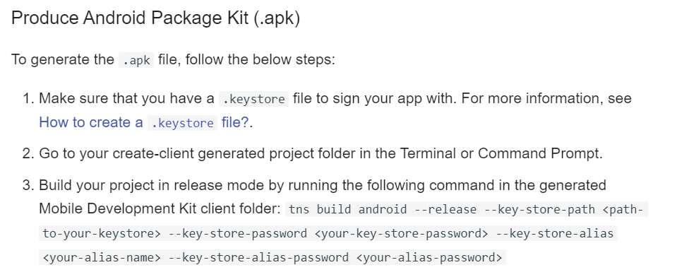

https://docs.oracle.com/cd/E19509-01/820-3503/ggfen/index.html

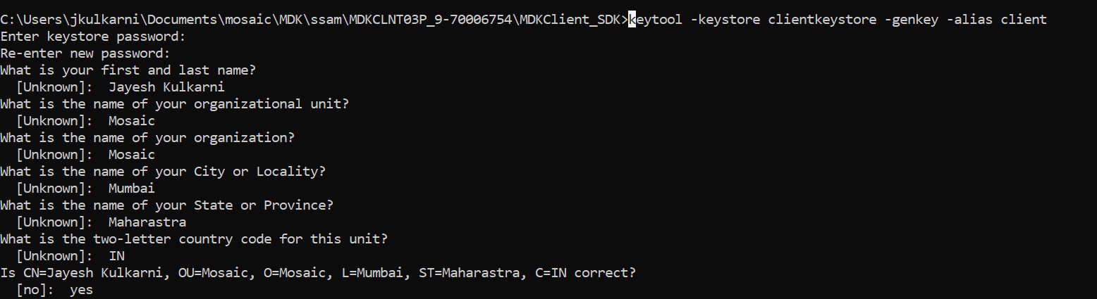

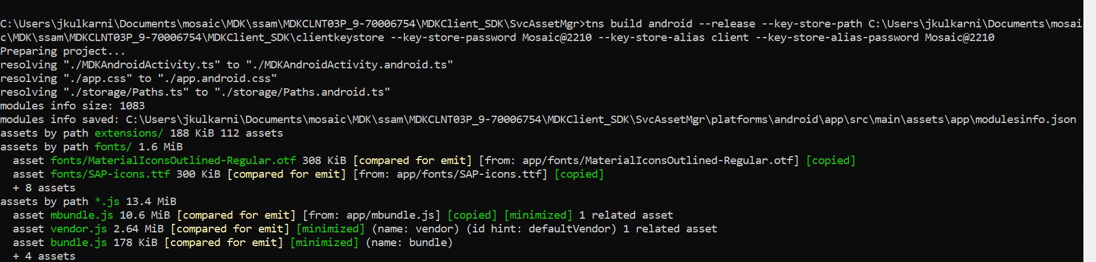

The build result is located at: C:\Users\jkulkarni\Documents\mosaic\MDK\ssam\MDKCLNT03P_9-70006754\MDKClient_SDK\SvcAssetMgr\platforms\android\app\build\outputs\apk\release\app-release.apk

keytool -keystore clientkeystore -genkey -alias client

keytool.exe -genkey -v -keystore release.keystore -alias client -keyalg RSA -keysize 2048 -validity 10000
tns build android --release --key-store-path C:\Users\jkulkarni\Documents\mosaic\MDK\ssam\MDKCLNT03P_9-70006754\MDKClient_SDK\release.keystore --key-store-password M0sa!c@2210 --key-store-alias client --key-store-alias-password M0sa!c@2210

Hi Gaurvav,
Your question/issue is not a SAP product issue or question. You can reach out to Android Studio Support or use internet resources that you can easily google, to setup Android Studio for signing, etc. In the SAP spirit of helping customers, I will try to give you some guidance.
First for the error, you should check that your keystore file is valid, check that the signing certificate in that keystore is from a trusted CA, and lastly, you can try to first do the signing outside of the Android Studio or even using the "tns build" command.
To do it outside of Android Studio, use the following commands. Please modify those commands, in particular, the keystore password, key password and the CN.
Keystore/key creation:
keytool -genkey -v -keystore /tmp/temp.keystore -keyalg RSA -keysize 2048 -validity 10000 -alias temp -storepass test123 -keypass test123 -dname "CN=temp"
Now you can either sign using the Android SDK apksigner tool:
apksigner sign --ks-pass "pass:test123" --key-pass "pass:test123" --ks /tmp/temp.keystore --ks-key-alias "temp" your.apk
OR, you can pass the keystore as part of your SAM app build command (make sure to use the --release option):
tns build android --release --key-store-path /tmp/temp.keystore --key-store-password test123 --key-store-alias temp --key-store-alias-password test123

Hope it helps.
Samir
PS:
Also, I made several suggestions in my previous comments and haven't heard back either.

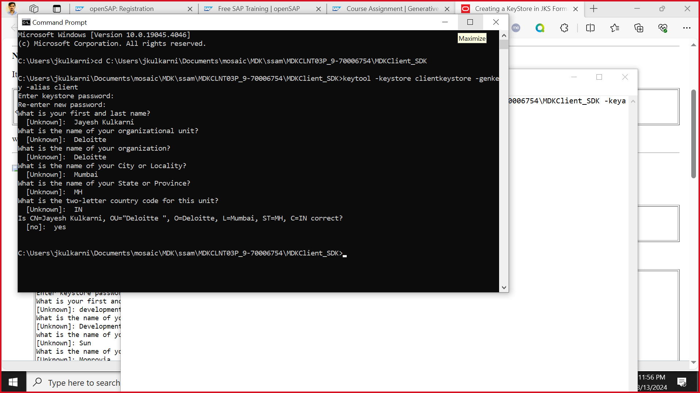

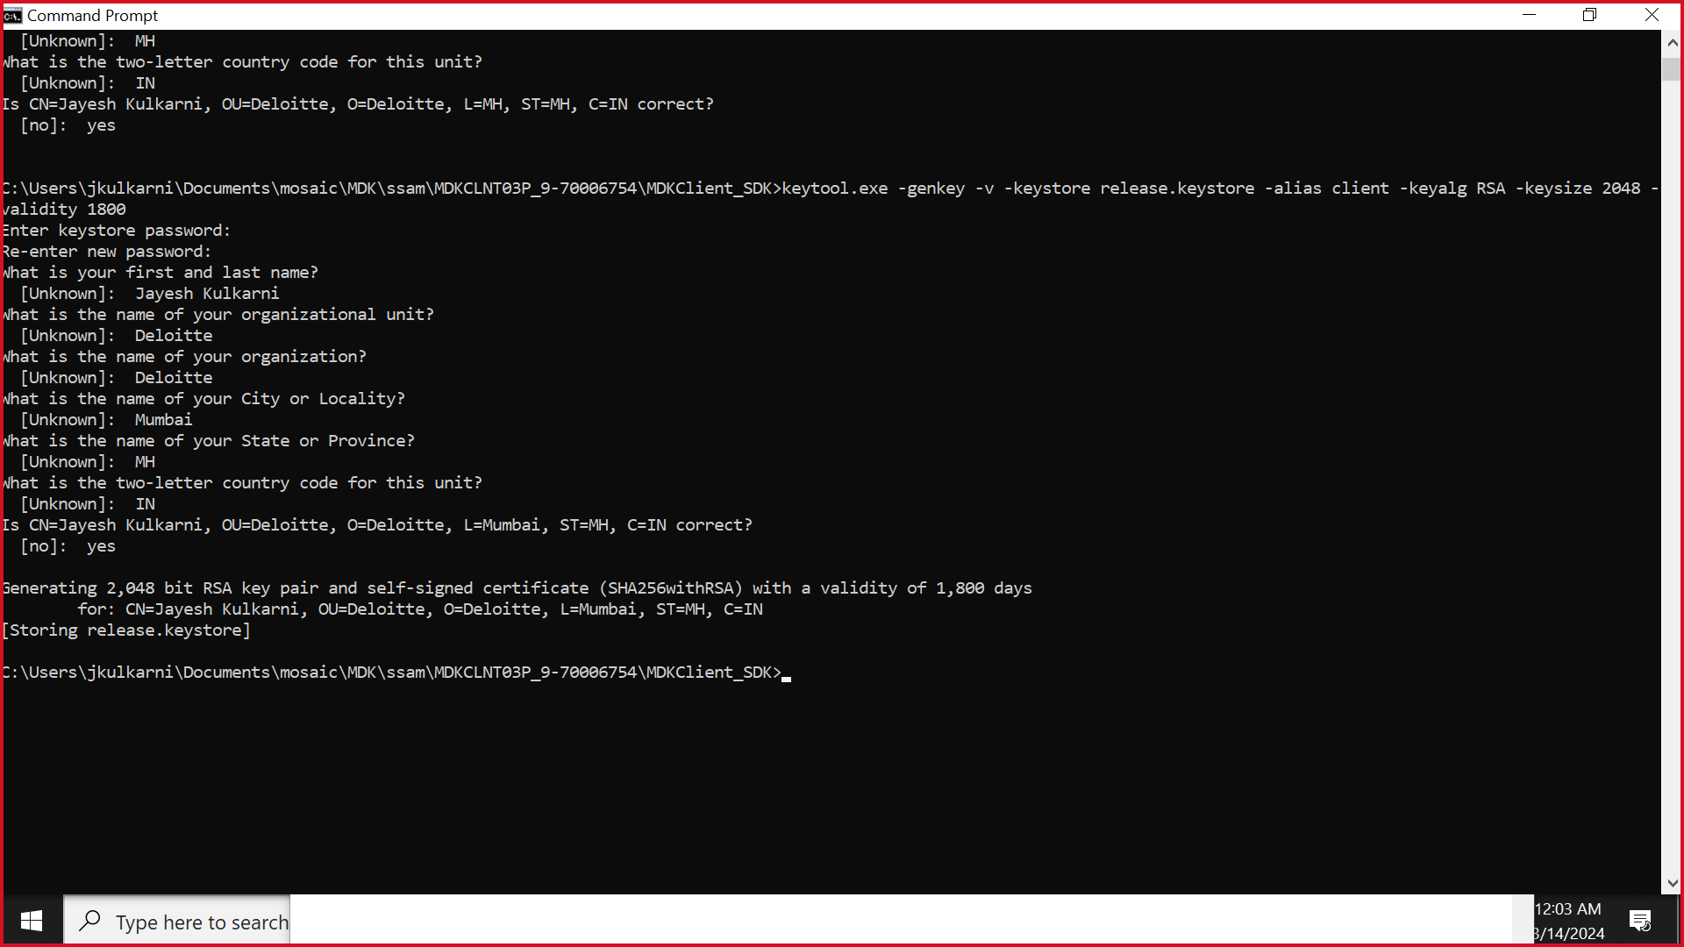

Process 1:
- Copy latest code from BAS
- Change bundle Id in mdkproject.json and app.gradle file to QA unique name
- Update connection settings in brandedsettings.json to QA mobile service.
- Build using command tns build android --release --key-store-path C:\Users\jkulkarni\Documents\mosaic\MDK\ssam\MDKCLNT03P_9-70006754\MDKClient_SDK\release.keystore --key-store-password M0sa!c@2210 --key-store-alias client --key-store-alias-password M0sa!c@2210
- Check APK using Sixo Online APK Analyzer | sisik. Updated ID should appear in the app ID.

Process 2 (If process 1 doesn’t work and Id in not updated)
- Copy Code from BAS
- Delete s/SAPAssetManagerExt/Web/App_Resources/README from .mdkproject metadata
- ns build android
- changes in androidmanifest.xml and android:extractNativeLibs="true" and in app.gradle abiFilters (only keep 64 bit)
- updated bundle ID "com.sap.sam.mosaic.dev.release.first" to "com.sap.sam.mosaic.qa.release.first" in mdkproject.json
- updated QA service connection settings in brandedsettings.json --> use mobile settings exchanges -->info
- Build using command tns build android --release --key-store-path C:\Users\jkulkarni\Documents\mosaic\MDK\ssam\MDKCLNT03P_9-70006754\MDKClient_SDK\release.keystore --key-store-password M0sa!c@2210 --key-store-alias client --key-store-alias-password M0sa!c@2210
- Check APK using Sixo Online APK Analyzer | sisik. Updated ID should appear in the app ID.

